|  |  |
| --- | --- |
| Hiring Task | Abstract  Small research analytics on the social media trends.  Sarthak Rathore  sarthakrathore38@gmail.com |

**1)Best time to post on social media’s.**

#### **When To Post on Instagram During the Coronavirus Pandemic?**

Data collected during the coronavirus pandemic showed significant changes in social media behavior. As people shifted both their professional and personal lives online and from home, social media usage increased dramatically.

This caused a change in the hours during which users were more engaged and interactive and consequently, the best times to post.

Because of COVID-19, the current best times to post on Instagram has expanded to three days a week on Mondays, Tuesdays, and Fridays. It continues to be the hour just before lunch at 11 a.m., and there’s even a peak in engagement on Tuesdays at 2 p.m.

### **When to Post on Facebook?**

Pre-COVID-19, the best times to post on [your Facebook business page](https://www.oberlo.com/blog/facebook-business-page) were on Wednesdays at 11 a.m. and between 1 p.m. and 2 p.m as activity on the platform increased in the middle of the week .

Tuesdays to Thursdays were also considered to be rather safe days to post on Facebook, especially during the day between 8 a.m. and 3 p.m.

* The best time to post on Facebook was on Wednesdays at 11 a.m. and from 1 p.m. to 2 p.m.
* The worst day to post was on Sunday.

#### **When To Post on Facebook During the Coronavirus Pandemic?**

As Facebook usage grew during lockdown, so did activity throughout the week. This has led to larger windows during which to post on Facebook for more engagement.

The best times to post on Facebook during the coronavirus pandemic are on Mondays, Wednesdays, and Fridays from 10 a.m. to 11 a.m. Weekends continue to be the worst time to post, alongside weekdays after 5 p.m.

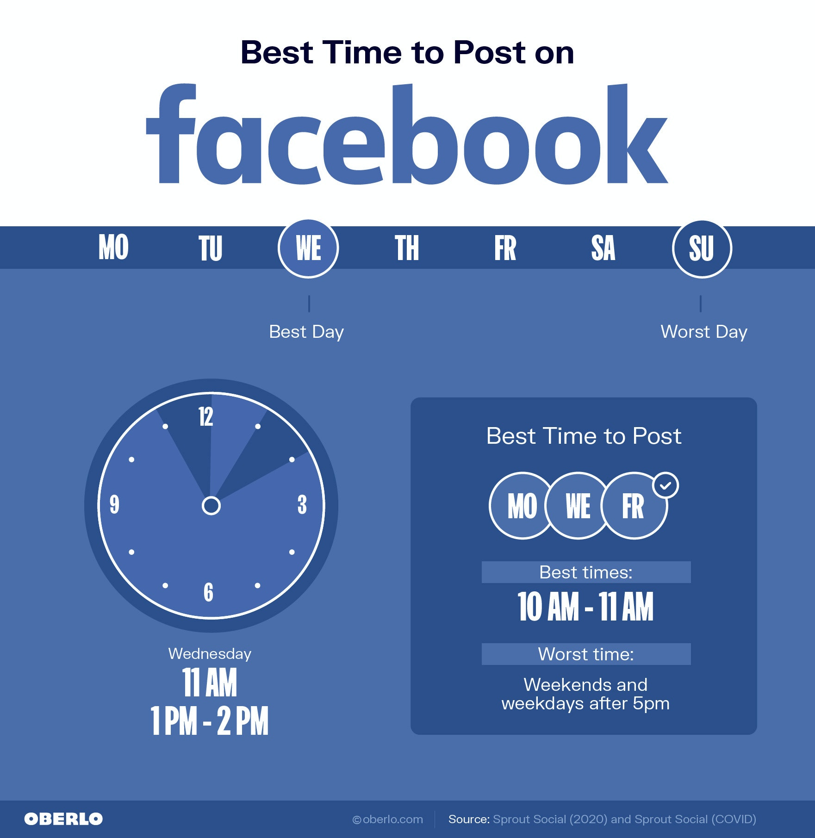

### **When Is the Best Time to Post on Linkedin?**

Unlike Instagram and Facebook, LinkedIn is a professional social network used by recruiters, salespeople, and business people, which they use for work.

Pre-COVID-19, the best times to post on LinkedIn were during the workweek and in the mornings Specifically:

* Wednesdays between 8 a.m. and 10 a.m. and at noon
* Thursdays at 9 a.m. and between 1 p.m. and 2 p.m.
* Friday mornings at 9 a.m.

#### **When To Post on LinkedIn During the Coronavirus Pandemic?**

Behavior on LinkedIn has stayed largely the same during the pandemic in that users tend to be more active in the mornings on weekdays.

The best times to post on LinkedIn during the coronavirus pandemic are:

* Wednesdays at 3 p.m.
* Thursdays between 9 a.m. and 10 a.m.
* Fridays between 11 a.m. and 12 p.m.

Weekends and after-work hours tend to be the worst times to post on LinkedIn for engagement and visibility .

### Best time to post on LinkedIn

### **When to Post on Twitter?**

Twitter users tend to catch up on the latest news and tweets in the early morning. This is why the best times to post on [Twitter for your business](https://www.oberlo.com/blog/twitter-for-business-ultimate-guide) are on Wednesdays and Fridays at 9 a.m.

Usage patterns have remained largely the same during COVID-19 times. The only change has been to Friday mornings, which have seen heightened activity between 7 a.m. and 9 a.m. and peaking towards the latter hour .

* Wednesdays and Fridays are the best days to post on Twitter. Weekends are the worst days to post on Twitter.

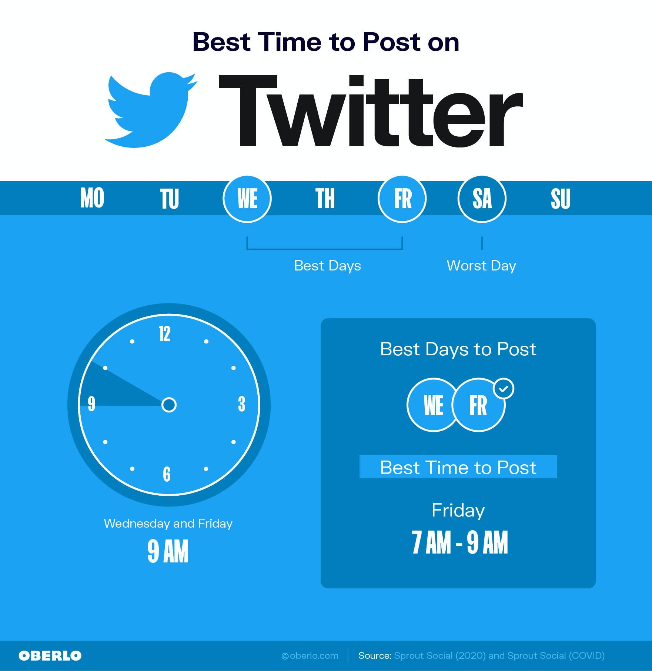

### **When is the Best Time to Publish Videos on YouTube?**

The best time to publish videos on YouTube is in the afternoon between 2 p.m. and 4 p.m. That’s because most viewers watch videos in the evening. Between 7 p.m. and 10 p.m. is when YouTube receives the most traffic, so you’ll want to have your videos indexed by then ([How Sociable](https://howsociable.com/blog/best-time-to-post-on-youtube/), 2020).

* Thursdays and Fridays tend to be the best days to post on YouTube.
* Mondays, Tuesdays, and Fridays are the worst days to post on YouTube as people return to work and have less time to browse on YouTube.

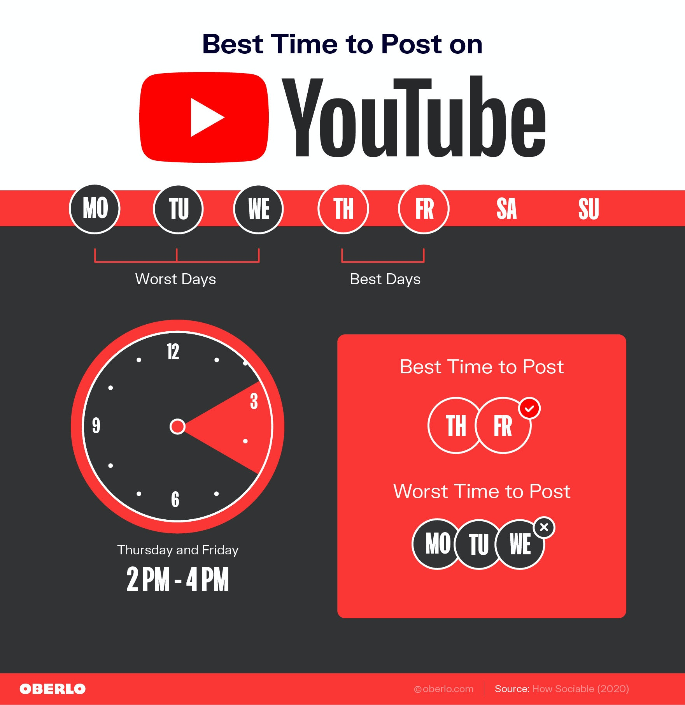

Google Analytics Report for Social Media Reporting

Once you’ve [built an audience](https://www.oberlo.com/blog/social-media-tips) and posted a few updates, you want to track your social media efforts. [Google Analytics](https://www.oberlo.com/blog/google-analytics-ecommerce-business) has all the data you need to decide the right times to post on social media. All you need to do is set up Custom Reports for each platform and start analyzing information.

Let’s walk through this process together.

1. Click on ‘Custom Reports’ in the left-hand side toolbar on Google Analytics.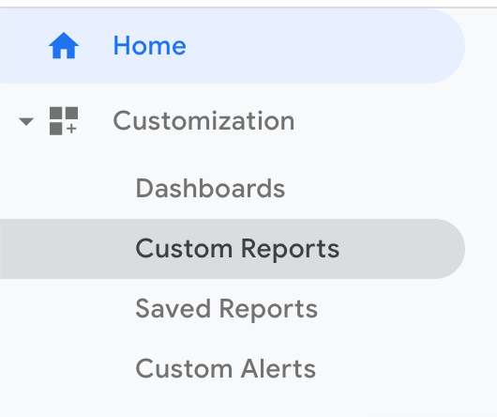
2. Select ‘New Custom Report’ to start creating your report.  
   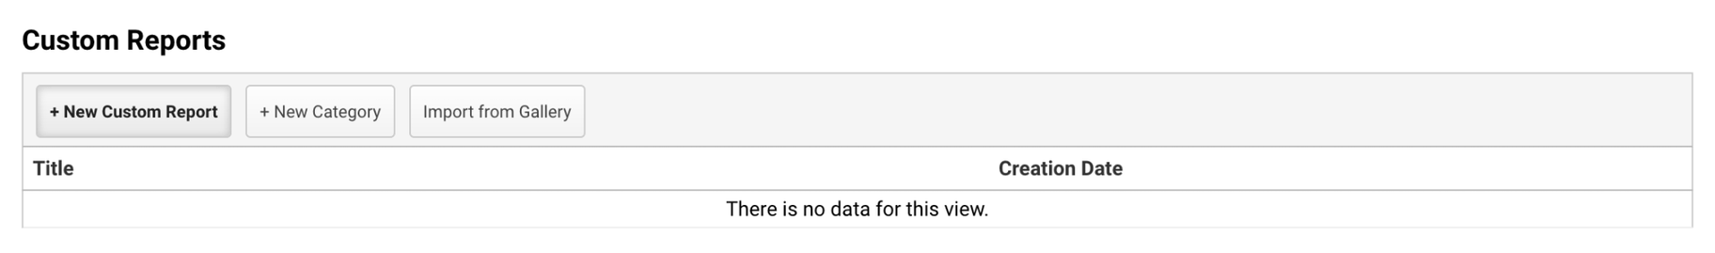
3. Choose the information you want to see in your report. Below is a basic report for Facebook to show you how to fill in the appropriate fields but you can add up to ten  
   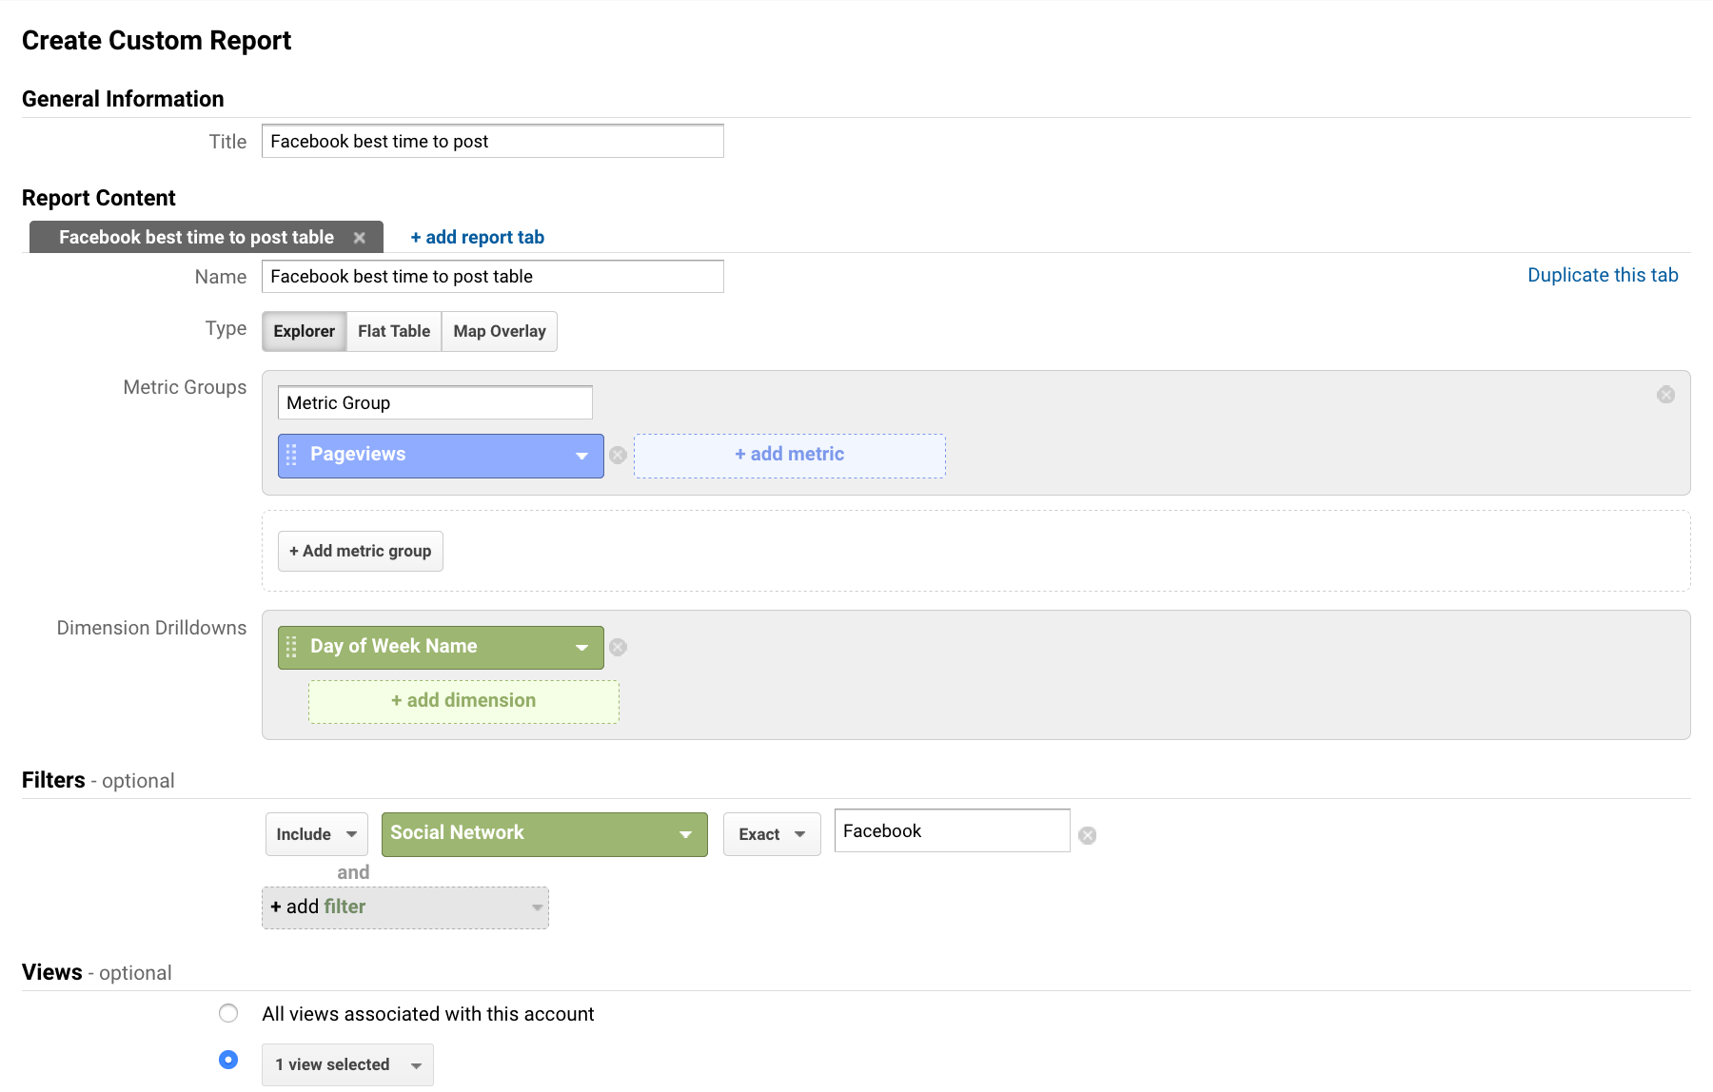
4. Save the report and view your results. To view the hours of the day simply choose ‘Hour’ as your secondary dimension.  
   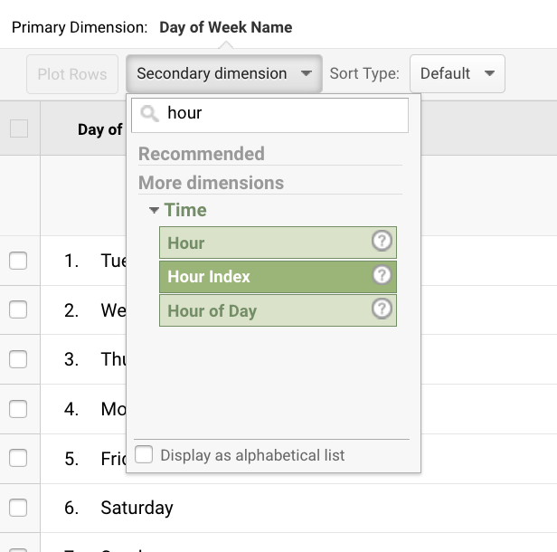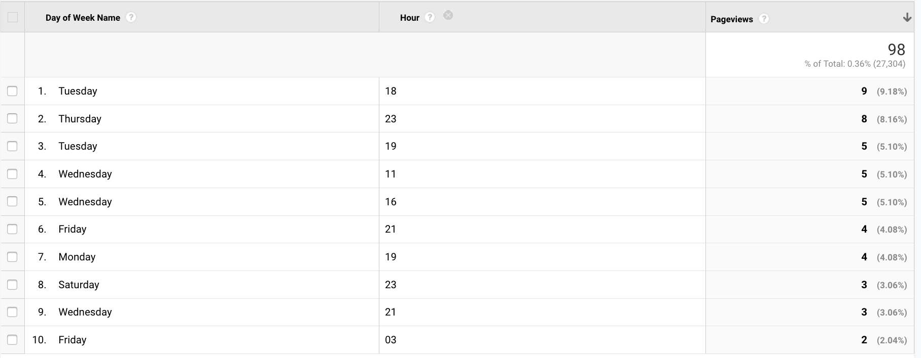
5. Repeat for all important social media traffic providers.
6. Start crafting your social media schedule around your best times to post.
7. Use custom reports to track progress and success.

## **Social Media Management Tools**

After creating your social media schedule, you can use[social media marketing automation and management tools](https://www.oberlo.com/blog/social-media-tools) like[Buffer](https://buffer.com/),[Later](https://later.com/),[Hootsuite](https://hootsuite.com/) or choose from this list of [Instagram tools](https://www.shopify.com/blog/instagram-tools) to schedule posts at a future time.

These tools can help you stay consistent when posting on social media, helping you reach followers even while you’re sleeping. They can also be used for testing different times to determine which times [get the best engagement.](https://www.oberlo.com/blog/social-media-engagement) Plus, you can leverage these tools to schedule the same post several times to reach every time zone or drive traffic back to your website.

It is highly advised to post on these times to get better and more audience attention.

**2)Which platforms we can be more live or active to connect to maximum youth except for Internshala?**

This generally depends upon the format of the post(i.e long video,short video,or a general post)and the targeted audience.

YouTube is more preferable platform for long videos while Instagram and FaceBook is preferable for short videos(reels).

Twitter is mostly used for announcement while platforms like Linkedin is used to show achievements.

**3)Keywords and hashtags the organization should use during posts**

Hashtags should always be related to the content and should relate to some real life incident. Hashtage can also be related to some reports .

**4)What are the things needed to be improved on the social platforms of SBF**

The comments on most of the posts like on Instagram and YouTube aren’t replied .It would be great if someone from the team replies to the comments as people like attention.

5)What are the other most important strategies for raising funds

Potential doners should always be notified about the fundraisers via E-Mail .They should also be told about how their money has impacted the cause for good for them to feel happy and also to fund another project . They should also be greeted on festivals and on birthdays via E-Mail as this creates a healthy bond.

These were the few strategies I would like to pitch to the organization to make it’s digital presence much stronger.

Thank you for going through this read!